**Sprint – 2 (Data Visualization Chart)**

**Team ID:** PNT2022TMID42593

**Project Name:** Estimate the Crop Yield Using Data Analytics

**TO CREATE THE DATA VISUALIZATION CHART IN IBM COGNOS**

* Build A Visualization to Showcase Average Crop Production by Seasons.
* Showcase The Yearly Usage of Area in Crop Production.
* Build A Visualization to Show Case Top 10 States in Crop Yield Production by Area.
* Build The Required Visualization to Showcase the Crop Production by State.

*Build Visual Analytics to Represent the Sates with Seasonal Crop Production Using a Text Representation.

# Different Season with Average Production

As production of crops depends on different seasons, so let’s plot the graphs to visualize the average production based on different seasons. You can find the average productions briefing in this video.

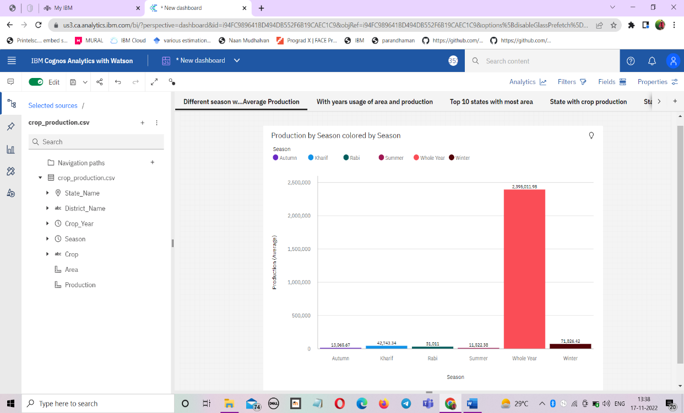

**With years usage of area and production**

In our dataset we also have a year’s columns by which we will plot a line and area graphs to see the change in these both data with respect to increase in years.

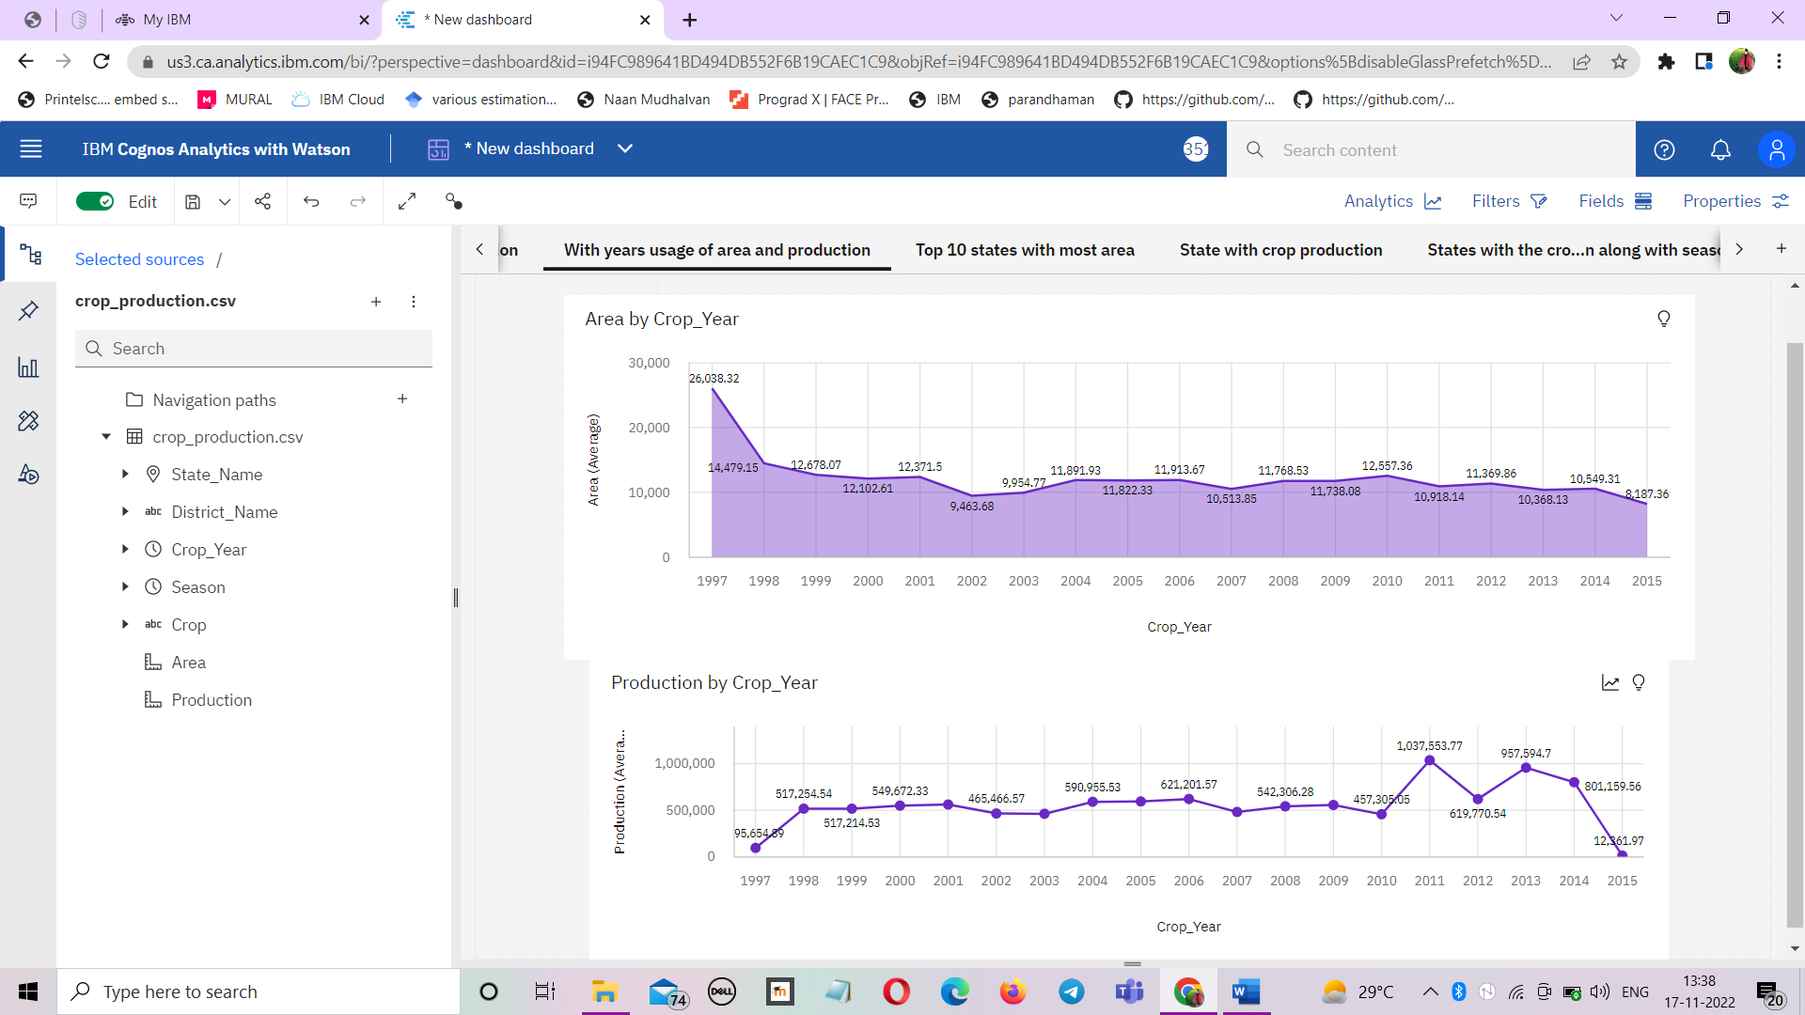

**Top 10 states with most area**

As we have an area data in our dataset, we will be plotting some graphs to visualize the top 10 Indian states with the most area.

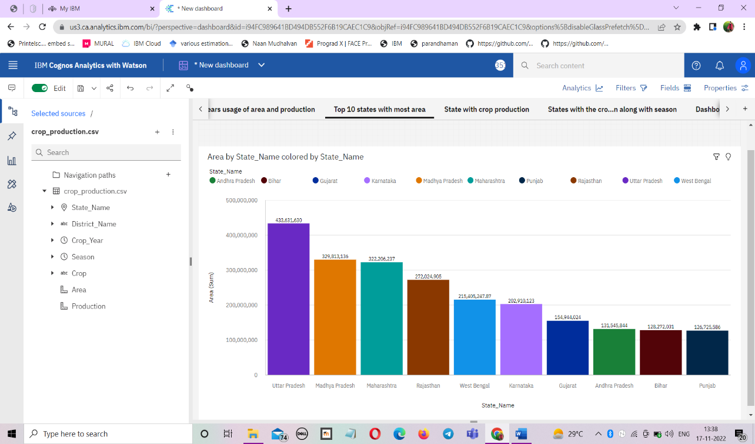

**States with crop production**

There are so many different crops produced in India and most of us don’t know which crop is belongsto which state so we will be plotting and highlight the states in map according to different crops.

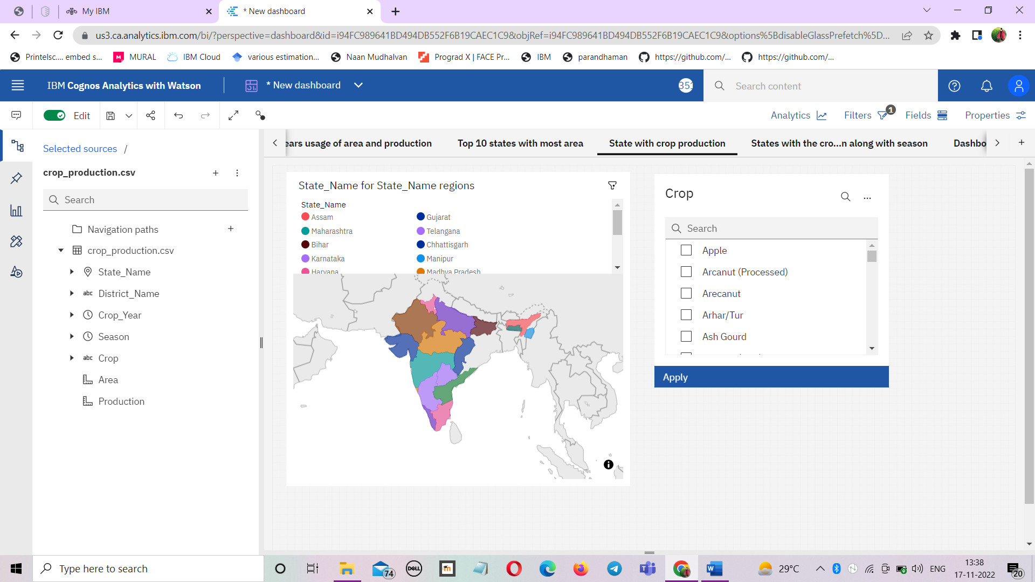

**States with crop along with season**

Taking forward the previous plot we will be fetching the state name and showing it in a text table whenever different crops are chosen.

